**Summary:**

# **Limitations of data**

Data is powerful, but it has its limitations. Has someone’s personal opinion found its way into the numbers? Is your data telling the whole story? Part of being a great data analyst is knowing the limits of data and planning for them. This reading explores how you can do that.







* **Compare the same types of data**: Data can get mixed up when you chart it for visualization. Be sure to compare the same types of data and double check that any segments in your chart definitely display different metrics.
* **Visualize with care**: A 0.01% drop in a score can look huge if you zoom in close enough. To make sure your audience sees the full story clearly, it is a good idea to set your Y-axis to 0.
* **Leave out needless graphs:** If a table can show your story at a glance, stick with the table instead of a pie chart or a graph. Your busy audience will appreciate the clarity.
* **Test for statistical significance:** Sometimes two datasets will look different, but you will need a way to test whether the difference is real and important. So remember to run statistical tests to see how much confidence you can place in that difference.
* **Pay attention to sample size**: Gather lots of data. If a sample size is small, a few unusual responses can skew the results. If you find that you have too little data, be careful about using it to form judgments. Look for opportunities to collect more data, then chart those trends over longer periods.



In any organization, a big part of a data analyst’s role is making sound judgments. When you know the limitations of your data, you can make judgment calls that help people make better decisions supported by the data. Data is an extremely powerful tool for decision-making, but if it is incomplete, misaligned, or hasn’t been cleaned, then it can be misleading. Take the necessary steps to make sure that your data is complete and consistent. Clean the data before you begin your analysis to save yourself and possibly others a great amount of time and effort.

A data analyst reframes a question. Then, they outline the problem, challenges, potential solutions, and timeframe. This is done to achieve what goals? Select all that apply:

* **Put the data in context, and find the story it’s telling**
* **Communicate expectations so stakeholders understand how long it will take to provide accurate information**
* **Balance speed with accuracy**

**Summary**

A colleague sent you a question via email nearly two days ago. You know it’s going to take a while for you to find the answer because you need to do some research first. You’re too busy to get it done today. What’s the best course of action:

*Reply with a quick update thanking the sender for their patience and letting them know when they can expect you to respond with the answer to their question.*

Focusing on stakeholder expectations enables data analysts to achieve what goals? Select all that apply.

* *Improve communication among teams*
* *Build trust*
* *Understand project goals*

A stakeholder has asked a data analyst to produce a report very quickly. What are some strategies the analyst can apply to ensure their work isn’t rushed, answers the right question, and delivers useful results? Select all that apply:

* *Reframe the question*
* *Set clear expectations about timeframe*
* *Outline the problem*

# Leading great meetings

One day soon, you might find yourself planning a meeting in your role as a data analyst. Great things can happen when participants anticipate a well-executed meeting. Attendees show up on time. They aren’t distracted by their laptops and phones. They feel like their time will be well spent. It all comes down to good planning and communication of expectations. The following are our best practical tips for leading meetings.



## **Before the meeting**

If you are organizing the meeting, you will probably talk about the data. Before the meeting:

* Identify your objective. Establish the purpose, goals, and desired outcomes of the meeting, including any questions or requests that need to be addressed.
* Acknowledge participants and keep them involved with different points of view and experiences with the data, the project, or the business.
* Organize the data to be presented. You might need to turn raw data into accessible formats or create data visualizations.
* Prepare and distribute an agenda. We will go over this next.

## **Crafting a compelling agenda**

A solid meeting agenda sets your meeting up for success. Here are the basic parts your agenda should include:

* Meeting start and end time
* Meeting location (including information to participate remotely, if that option is available)
* Objectives
* Background material or data the participants should review beforehand

Here's an example of an agenda for an analysis project that is just getting started:

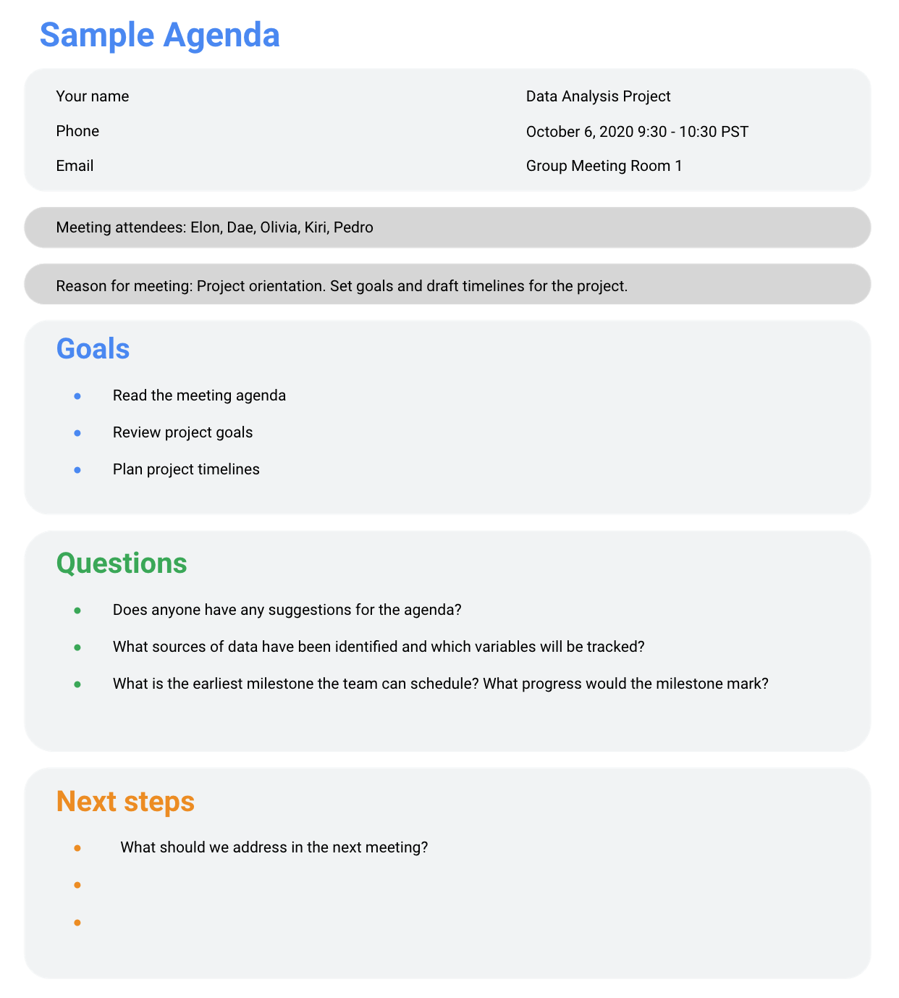

## **Sharing your agenda ahead of time**

After writing your agenda, it's time to share it with the invitees. Sharing the agenda with everyone ahead of time helps them understand the meeting goals and prepare questions, comments, or feedback. You can email the agenda or share it using another collaboration tool.

## **During the meeting**

As the leader of the meeting, it's your job to guide the data discussion. With everyone well informed of the meeting plan and goals, you can follow these steps to avoid any distractions:

* Make introductions (if necessary) and review key messages
* Present the data
* Discuss observations, interpretations, and implications of the data
* Take notes during the meeting
* Determine and summarize next steps for the group

## **After the meeting**

**T**o keep the project and everyone aligned, prepare and distribute a brief recap of the meeting with next steps that were agreed upon in the meeting. You can even take it a step further by asking for feedback from the team.

* Distribute any notes or data
* Confirm next steps and timeline for additional actions
* Ask for feedback (this is an effective way to figure out if you missed anything in your recap)

## **A final word about meetings**

Even with the most careful planning and detailed agendas, meetings can sometimes go off track. An emergency situation might steal people’s attention. A recent decision might unexpectedly change requirements that were previously discussed and agreed on. Action items might not apply to the current situation. If this happens, you might be forced to shorten or cancel your meeting. That's all right; just be sure to discuss anything that impacts your project with your manager or stakeholders and reschedule your meeting after you have more information.